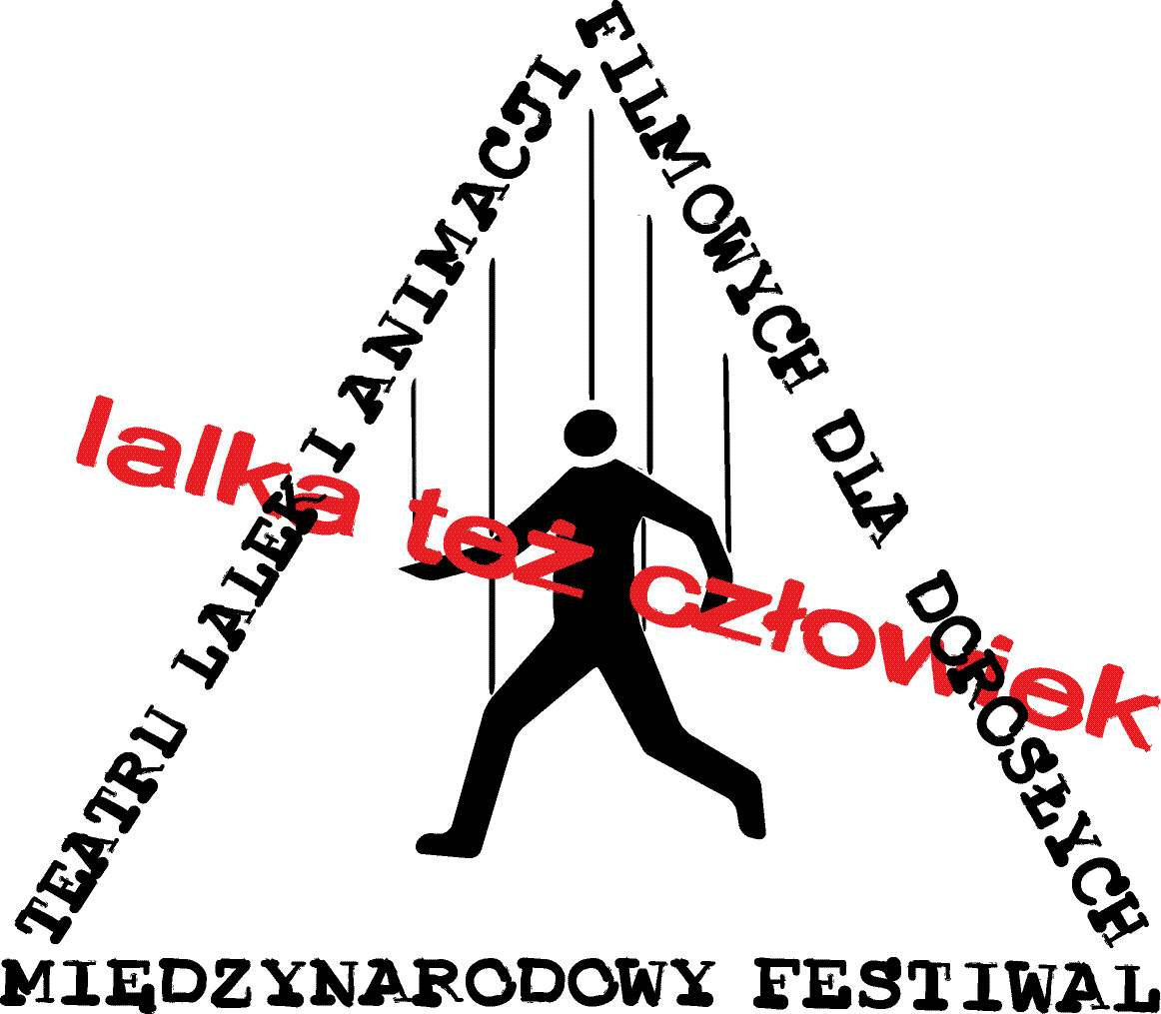
INTERNATIONAL FESTIVAL
of PUPPET THEATRES and ANIMATED FILMS
for ADULTS
“Puppet is a Human, too”

Warsaw, October 5th – 12th 2019

Company name:

........................................................................................................................................

Performance title:

........................................................................................................................................

Please use single quotation marks for quotations, ensure that all quotations are correct and attributed, italics for show titles and publication names, and please do not use bold type or other style formatting in this document.

Information for the Festival's folder

Recommend us your show using 150 words or less (without stating show’s title, company’s name, creator’s name nor names of the performers):

........................................................................................................................................

........................................................................................................................................

Please provide a details about the authors and performers of your production:

........................................................................................................................................

........................................................................................................................................

100-200 word of information about your company - for example past awards for the company
or company members:

........................................................................................................................................

........................................................................................................................................

If your production or company has a website, please provide the addresses:

........................................................................................................................................

Is your performance or trailer available on Vimeo or YouTube? If so, please share the link:

........................................................................................................................................

Is your piece produced in association with a partner organization such as a school, sponsor, arts body, society, charity or production management company?

........................................................................................................................................

The preferred date of presentation of your performance:

........................................................................................................................................

What is the total number of people involved in the show (actors, technicians, others)?

........................................................................................................................................

How long can the band be hosted at the Festival?

........................................................................................................................................

What are your financial expectations (in PLN)?

........................................................................................................................................

In case of acceptance by the Selection Committee a current fiscal Residence Certificate is required. It is available
to get in Fiscal Government in your country. In other case we have to pay about 20% tax from your fee in Poland.

Preferred kind of rooms for your team (single or double rooms):

........................................................................................................................................

Other special request (e.g. vegetarian or vegan diet – please provide as much information as you can):

........................................................................................................................................

Technical specifications

Stage’s area and type required for your production:

........................................................................................................................................

........................................................................................................................................

set-up time: ……………… strike time: ……………… running time: ………………

Technical requirements:

........................................................................................................................................

........................................................................................................................................

........................................................................................................................................

Other:

........................................................................................................................................

Contact information:

........................................................................................................................................
Please return filled out form via email to ltc.marekzurawski@gmail.com or by providing all the data directly in the email body.

Also You are kindly asked to send:
- a DVD of your performance
- 3-5 photos of your performance (dimension: 4000x3000px and resolution: min. 300dpi)

Please send the DVD to:
“Lalka Też Człowiek”
Marek Żurawski
ul. Jadźwingów 3 m. 40
02-692 Warszawa

Should you have any questions you are welcome to contact us via email:
ltc.marekzurawski@gmail.com

or by calling us on:
+48 (22) 857 9955 between 10am and 9.00 pm (Mon-Fri).
mob. +48 606 495 854

Marek Zurawski - Managing Director
